LAB-1(HTML)

main.html

<html>

    <frameset rows="30%,10%,*">

        <frame src="one.html"></frame>

        <frame src="two.html"></frame>

        <frameset cols="20%,*">

            <frame src="three.html"></frame>

            <frame src="four.html"></frame>

        </frameset>

    </frameset>

</html>

OUTPUT:

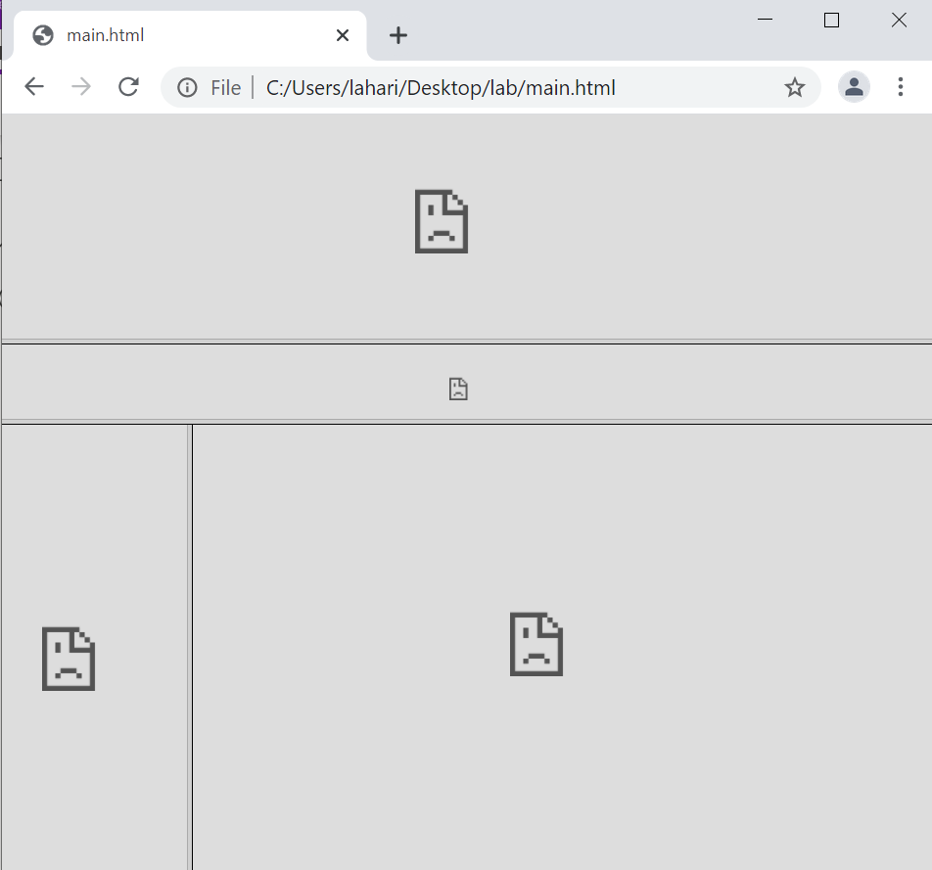

One.html

<html>

    <style>

        body{

            line-height: 1ch;

        }

h3{

padding-left:5%;

}

    </style>

    <body >

        <h3>18B91A12D6 </h3>

        <div style="text-align: center;">

            <h2 style="color:brown;">ONLINE BOOKS PLAZA</h2> <br>

            <img src="img1.png" alt="logo" width=700 height=100>

        </div>

    </body>

</html>

OUTPUT:



Two.html

<html>

    <body style="background-color:#eac8af;text-align:center;">

        <a href="four.html" target="four">Home</a>&nbsp; &nbsp; &nbsp; &nbsp; &nbsp; &nbsp; &nbsp; &nbsp;

        <a href="login.html" target="four">Login</a>&nbsp; &nbsp; &nbsp; &nbsp; &nbsp; &nbsp; &nbsp; &nbsp;

        <a href="register.html" target="four">Register</a>&nbsp; &nbsp; &nbsp; &nbsp; &nbsp; &nbsp; &nbsp; &nbsp;

        <a href="#catalogue">Catalogue</a>&nbsp; &nbsp; &nbsp; &nbsp; &nbsp; &nbsp; &nbsp; &nbsp;

        <a href="#cart">Cart</a>&nbsp; &nbsp; &nbsp; &nbsp; &nbsp; &nbsp; &nbsp; &nbsp;

    </body>

</html>

OUTPUT:

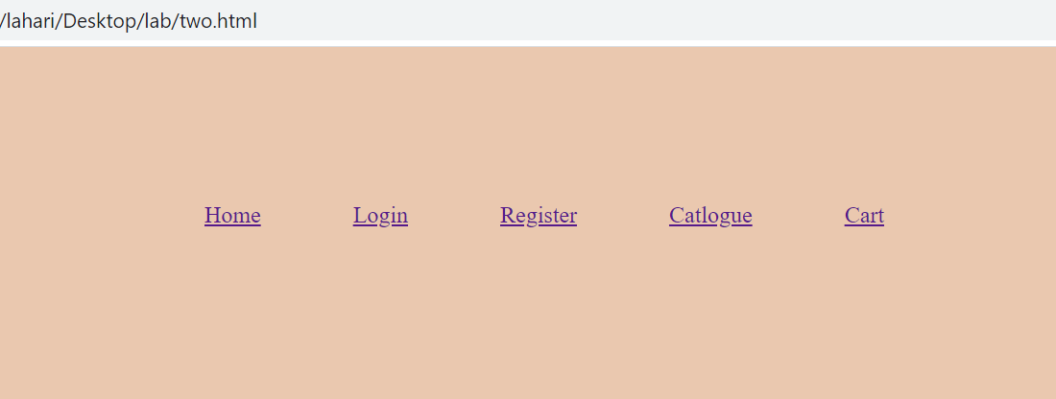

Three.html

<html>

    <body style="background-color:#d0af84;">

        <ul>

            <a href="#comics">Comics</a><br><br>

            <a href="#horror">Horror</a><br><br>

            <a href="#adventure">Adventure</a><br><br>

            <a href="#biography">Biography</a><br><br>

            <a href="#education">Education</a><br><br>

        </ul>

    </body>

</html>

OUTPUT:

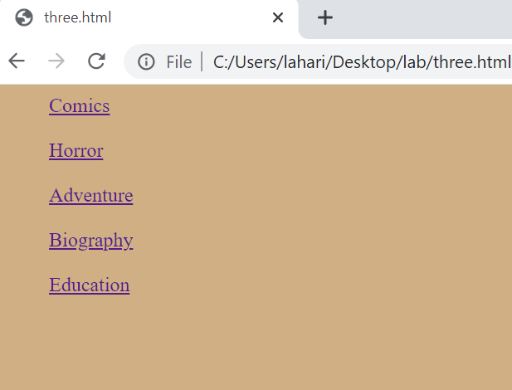

Four.html

<html>

    <body style="background-color:#d8ac9c;">

        <h1 style="color:antiquewhite";><marquee behavior="scroll" direction="left" scrollamount=12> India's Largest Online BookStore</marquee></h1>

        <p>With over 12 million books. Browse through variety of genres such as Fiction, Self help, Children's books, School textbooks, Higher education textbooks, and much more.

Explore Editor's corner, Exam Central, Indian Language Books, New Releases & Best sellers . Now available: Audible Audiobooks & more, Audible Membership</p>

    </body>

</html>

OUTPUT:

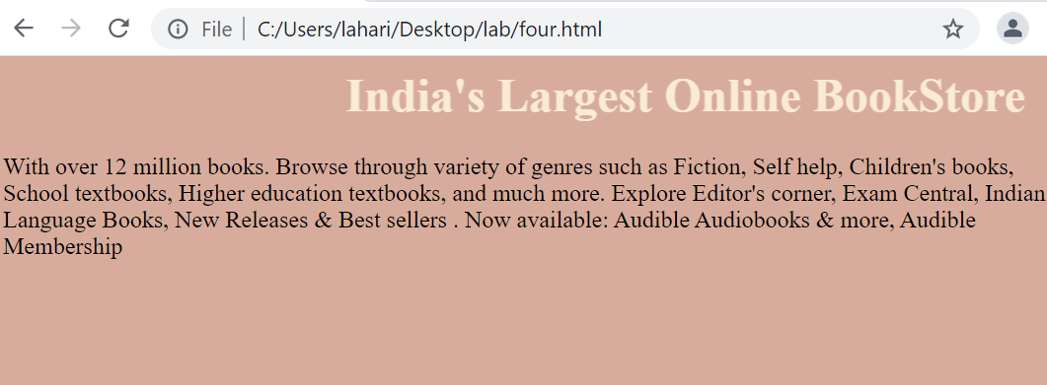

Login.html

<html>

    <body style="text-align:center;background-color:#d8ac9c;">

        <form action="#" method="post">

            <label for="name"><b>Username:</b></label>

            <input type="name" name="name" required="true"><br><br>

            <label for="password"><b>Password:</b></label>

            <input type="password" name="pwd"><br><br>

            <input type="button" value="login" width=50>&nbsp; &nbsp; &nbsp; &nbsp;

        </form>

        <p>Don't have an account?<a href="register.html">Sign up</a></p>

    </body>

</html>

OUTPUT:

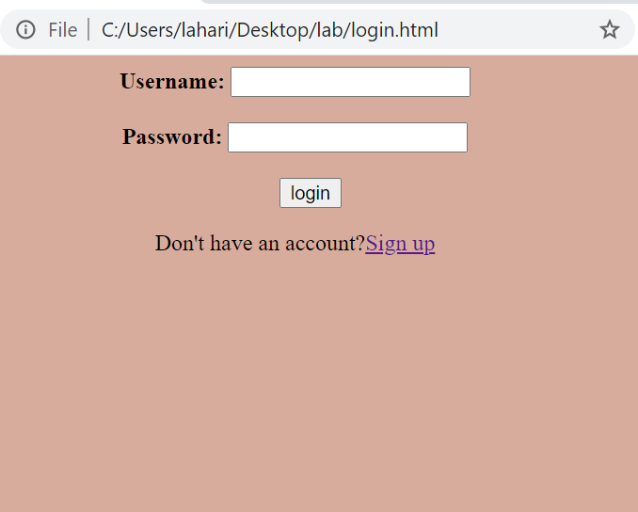

Register.html

<html>

    <head>

        <title>Registration page</title>

    </head>

    <body style="background-color:#d8ac9c;">

        <div align="center" >

           <h1>Registration Form</h1>

          <form action="#" method="post">

            <table border=0 cellpadding=2 width=50%>

                <tr>

                    <th>Name:</th>

                    <td>

                        <input type="textfield" name="text">

                    </td>

                </tr>

                <tr>

                    <th>Password:</th>

                    <td>

                        <input type="password" name="psw" pattern="(?=.*\d)(?=.*[a-z])(?=.*[A- Z]).{8,}" title="Must contain at least one number and one uppercase and lowercase letter, and at least 8 or more characters" required="true">

                    </td>

                </tr>

                <tr>

                    <th>Email</th>

                    <td>

                        <input type="text" placeholder="@gmail.com">

                    </td>

                </tr>

                <tr>

                    <th>Phone number:</th>

                    <td>

                        <select name="phn" id="phn">

                            <option value="+91">+91</option>

                            <option value="+49">+49</option>

                            <option value="+380">+380</option>

                            <option value="+12">+12</option>

                        </select>

 <input type="text" name="phn">

                    </td>

                </tr>

                <tr>

                    <th>Gender:</th>

                    <td>

                        <input type="radio" id="male" name="gender" value="male">Male<br>

                        <input type="radio" id="female" name="gender" value="female">Female<br>

                    </td>

                </tr>

                <tr>

                    <th>Date of birth:</th>

                    <td>

                        <input type="date" name="dob">

                    </td>

                </tr>

                <tr>

                    <th>Languages Known:</th>

                    <td>

                        <input type="checkbox" name="eng">English<br>

                        <input type="checkbox" name="hin">Hindi<br>

                        <input type="checkbox" name="ger">Germany<br>

                        <input type="checkbox" name="spa">Spanish<br>

                    </td>

                </tr>

                <tr>

                    <th>Address:</th>

                    <td>

                        <textarea name="text" id="text" cols="30" rows="5"></textarea>

                    </td>

                </tr>

            </table>

            <div align="center">

                <input type="submit" value=Submit>&nbsp;&nbsp;&nbsp;

                <input type="reset" value="Reset">

            </div>

        </form>

        </div>

    </body>

</html>

OUTPUT:

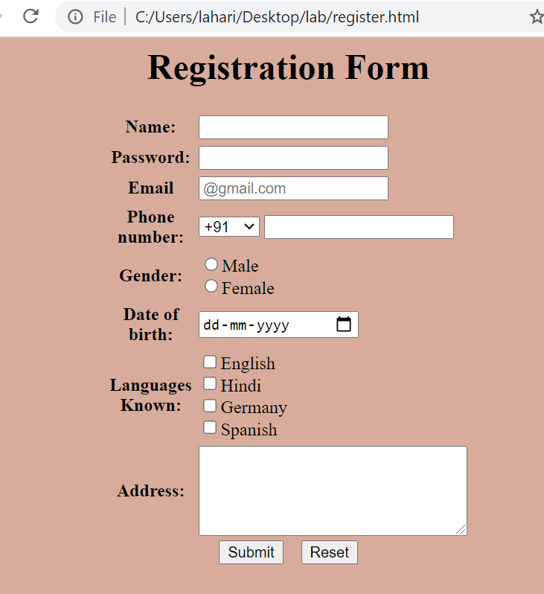

Catalogue.html

<html>

    <head>

        <title></title>

    </head>

    <body style="background-color:#d8ac9c;">

        <a name="comics"></a>

        <table border=1 width=100%>

            <tr>

                <th colspan=4>Comics</th>

            </tr>

            <tr align="center">

                <td><img src="c1.jpg" alt="comics" width=100 height=100></td>

                <td>

                    <b>Book:</b>3 rays <br>

                    <b>Author:</b>Satyajit Ray <br>

                    <b>Rating:⭐⭐⭐⭐</b>

                </td>

                <td>₹648</td>

                <td><input type="button" name="b1" value="Add to cart"></td>

            </tr>

            <tr align="center">

                <td><img src="c2.jpg" alt="comics" width=100 height=100></td>

                <td>

                    <b>Book:</b>Tintin in Tibet <br>

                    <b>Author:</b>Herge<br>

                    <b>Rating:⭐⭐⭐⭐</b>

                </td>

                <td>₹358</td>

                <td><input type="button" name="b2" value="Add to cart"></td>

            </tr>

            <tr align="center">

                <td><img src="c3.jpg" alt="comics" width=100 height=100></td>

                <td>

                    <b>Book:</b>Tinkle Digest <br>

                    <b>Author:</b>Anath Pai<br>

                    <b>Rating:⭐⭐⭐</b>

                </td>

                <td>₹350</td>

                <td><input type="button" name="b3" value="Add to cart"></td>

            </tr>

            <tr align="center">

                <td><img src="c4.jpg" alt="comics" width=100 height=100></td>

                <td>

                    <b>Book:</b>Avengers vs. Thanos<br>

                    <b>Author:</b>Steve Englehart <br>

                    <b>Rating:⭐⭐⭐⭐⭐</b>

                </td>

                <td>₹1068</td>

                <td><input type="button" name="b4" value="Add to cart"></td>

            </tr>

        </table>

        <a name="thriller"></a>

        <table border=1 width=100%>

            <tr>

                <th colspan=4>Thriller</th>

            </tr>

            <tr align="center">

                <td><img src="t1.jpg" alt="thriller" width=100 height=100></td>

                <td>

                    <b>Book:</b>If Tomorrow Comes  <br>

                    <b>Author:</b>Sidney Sheldon<br>

                    <b>Rating:⭐⭐⭐⭐</b>

                </td>

                <td>₹238</td>

                <td><input type="button" name="b5" value="Add to cart"></td>

            </tr>

            <tr align="center">

                <td><img src="t2.jpg" alt="thriller" width=100 height=100></td>

                <td>

                    <b>Book:</b>The Text <br>

                    <b>Author:</b>Claire Douglas<br>

                    <b>Rating:⭐⭐⭐</b>

                </td>

                <td>₹263</td>

                <td><input type="button" name="b6" value="Add to cart"></td>

            </tr>

            <tr align="center">

                <td><img src="t3.jpg" alt="thriller" width=100 height=100></td>

                <td>

                    <b>Book:</b>The Lost Symbol <br>

                    <b>Author:</b>Dan Brown<br>

                    <b>Rating:⭐⭐⭐⭐</b>

                </td>

                <td>₹350</td>

                <td><input type="button" name="b7" value="Add to cart"></td>

            </tr>

            <tr align="center">

                <td><img src="t4.jpg" alt="thriller" width=100 height=100></td>

                <td>

                    <b>Book:</b>The girl in the room 105<br>

                    <b>Author:</b>Chetan Bhagat <br>

                    <b>Rating:⭐⭐⭐⭐⭐</b>

                </td>

                <td>₹299</td>

                <td><input type="button" name="b8" value="Add to cart"></td>

            </tr>

        </table>

        <a name="adventure"></a>

        <table border=1 width=100%>

            <tr>

                <th colspan=4>Adventure</th>

            </tr>

            <tr align="center">

                <td><img src="a1.jpg" alt="adventure" width=100 height=100></td>

                <td>

                    <b>Book:</b>Harry Potter and Curse Child <br>

                    <b>Author:</b>J.K Rowling<br>

                    <b>Rating:⭐⭐⭐⭐⭐</b>

                </td>

                <td>₹508</td>

                <td><input type="button" name="b9" value="Add to cart"></td>

            </tr>

            <tr align="center">

                <td><img src="a2.jpg" alt="adventure" width=100 height=100></td>

                <td>

                    <b>Book:</b>Game of Thrones<br>

                    <b>Author:</b>George RR Martin<br>

                    <b>Rating:⭐⭐⭐⭐⭐</b>

                </td>

                <td>₹399</td>

                <td><input type="button" name="b10" value="Add to cart"></td>

            </tr>

            <tr align="center">

                <td><img src="a3.jpg" alt="adventure" width=100 height=100></td>

                <td>

                    <b>Book:</b>2034<br>

                    <b>Author:</b>Elliot Ackerman <br>

                    <b>Rating:⭐⭐⭐⭐</b>

                </td>

                <td>₹350</td>

                <td><input type="button" name="b11" value="Add to cart"></td>

            </tr>

            <tr align="center">

                <td><img src="a4.jpg" alt="adventure" width=100 height=100></td>

                <td>

                    <b>Book:</b>Project Hail Mary<br>

                    <b>Author:</b>Andy Weir<br>

                    <b>Rating:⭐⭐⭐⭐⭐</b>

                </td>

                <td>₹610</td>

                <td><input type="button" name="b12" value="Add to cart"></td>

            </tr>

        </table>

        <a name="biography"></a>

        <table border=1 width=100%>

            <tr>

                <th colspan=4>Biographies</th>

            </tr>

            <tr align="center">

                <td><img src="b1.jpg" alt="biography" width=100 height=100></td>

                <td>

                    <b>Book:</b>Wings of Fire<br>

                    <b>Author:</b>A.P.J Abdul Kalam<br>

                    <b>Rating:⭐⭐⭐⭐⭐</b>

                </td>

                <td>₹508</td>

                <td><input type="button" name="b13" value="Add to cart"></td>

            </tr>

            <tr align="center">

                <td><img src="b2.jpg" alt="biography" width=100 height=100></td>

                <td>

                    <b>Book:</b>Three Thousand Stiches<br>

                    <b>Author:</b>Sudha Murty<br>

                    <b>Rating:⭐⭐⭐⭐</b>

                </td>

                <td>₹299</td>

                <td><input type="button" name="b14" value="Add to cart"></td>

            </tr>

            <tr align="center">

                <td><img src="b3.jpg" alt="biography" width=100 height=100></td>

                <td>

                    <b>Book:</b>The Theory of Everything<br>

                    <b>Author:</b>Stephen Hawking<br>

                    <b>Rating:⭐⭐⭐⭐</b>

                </td>

                <td>₹450</td>

                <td><input type="button" name="b15" value="Add to cart"></td>

            </tr>

            <tr align="center">

                <td><img src="b4.jpg" alt="biography" width=100 height=100></td>

                <td>

                    <b>Book:</b>The Diary of an Young Girl<br>

                    <b>Author:</b>Anne Frank<br>

                    <b>Rating:⭐⭐⭐⭐⭐</b>

                </td>

                <td>₹540</td>

                <td><input type="button" name="b16" value="Add to cart"></td>

            </tr>

        </table>

        <a name="engineering"></a>

        <table border=1 width=100%>

            <tr>

                <th colspan=4>Engineering</th>

            </tr>

            <tr align="center">

                <td><img src="e1.jpg" alt="engineering"width=100 height=100></td>

                <td>

                    <b>Book:</b>Introduction to ElectroDynamics<br>

                    <b>Author:</b>David J.Griffiths<br>

                    <b>Rating:⭐⭐⭐</b>

                </td>

                <td>₹518</td>

                <td><input type="button" name="b17" value="Add to cart"></td>

            </tr>

            <tr align="center">

                <td><img src="e2.jpg" alt="engineering" width=100 height=100></td>

                <td>

                    <b>Book:</b>The 8081 Microcontroller<br>

                    <b>Author:</b>Mohammad Ali<br>

                    <b>Rating:⭐⭐⭐⭐</b>

                </td>

                <td>₹499</td>

                <td><input type="button" name="b18" value="Add to cart"></td>

            </tr>

            <tr align="center">

                <td><img src="e3.jpg" alt="engineering" width=100 height=100></td>

                <td>

                    <b>Book:</b>Cryptography and Network Security<br>

                    <b>Author:</b>Forouzan  <br>

                    <b>Rating:⭐⭐⭐⭐⭐</b>

                </td>

                <td>₹550</td>

                <td><input type="button" name="b19" value="Add to cart"></td>

            </tr>

            <tr align="center">

                <td><img src="e4.jpg" alt="engineering" width=100 height=100></td>

                <td>

                    <b>Book:</b>Web Technologies<br>

                    <b>Author:</b>Uttam K Roy<br>

                    <b>Rating:⭐⭐⭐⭐⭐</b>

                </td>

                <td>₹610</td>

                <td><input type="button" name="b20" value="Add to cart"></td>

            </tr>

        </table>

    </body>

</html>

OUTPUT:

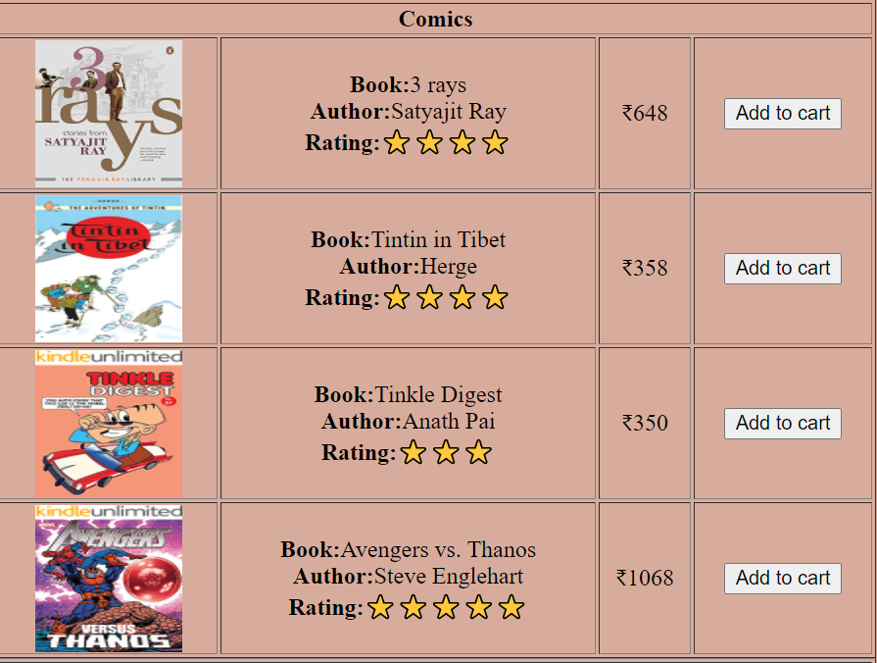

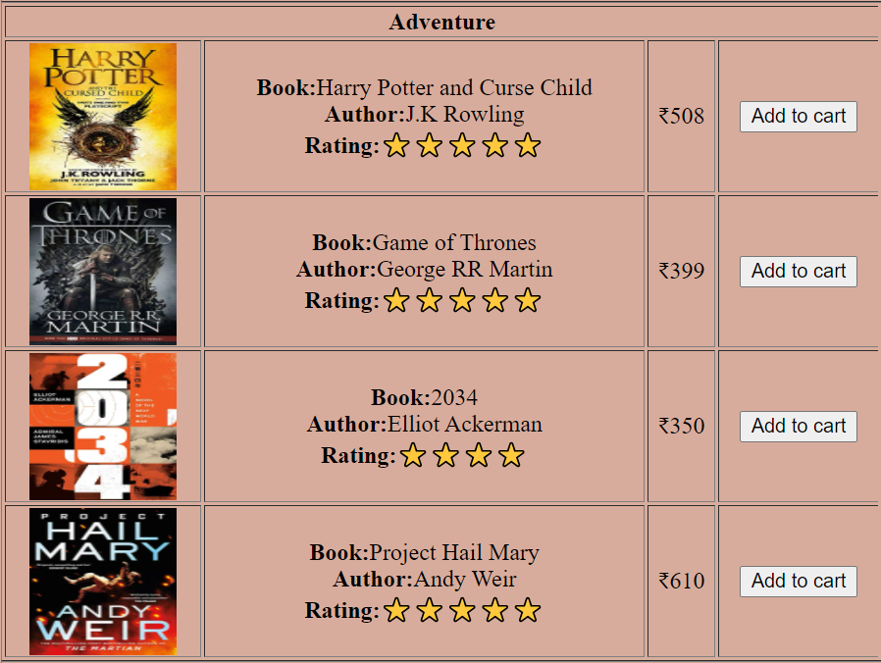



Cart.html

<html>

    <body style="text-align:center;background-color:#d8ac9c;">

        <center><h1 style="color:antiquewhite;">Your Cart</h1></center>

        <table border=1 width=100%>

            <tr>

                <th>BOOKS</th>

                <th>PRICE</th>

                <th>QUANTITY</th>

                <th>AMOUNT</th>

            </tr>

            <tr align="center">

                <td>If Tomorraow Comes</td>

                <td>₹238</td>

                <td>1</td>

                <td>₹238</td>

            </tr>

            <tr align="center">

                <td>Harry Potter and Curse Child</td>

                <td>₹508</td>

                <td>1</td>

                <td>₹508</td>

            </tr>

            <tr align="center">

                <td>Web Technologies</td>

                <td>₹610</td>

                <td>2</td>

                <td>₹1220</td>

            </tr>

            <tr align="center">

                <th colspan=3>Total Amount</th>

                <td>₹1966</td>

            </tr>

        </table>

    </body>

</html>

OUTPUT:

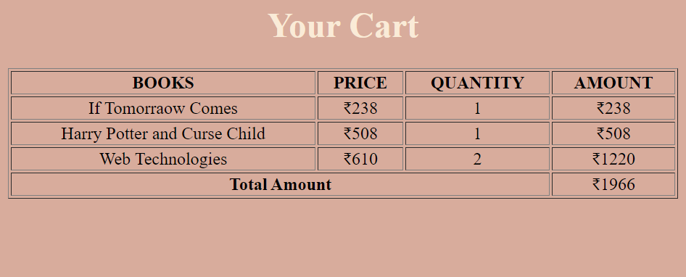

*Overall output*

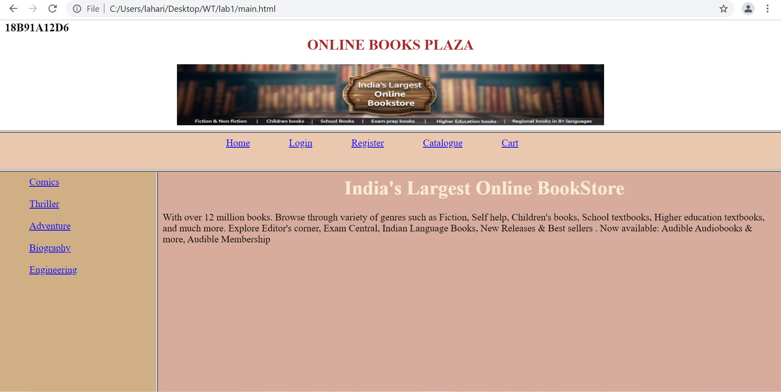

**LAB-2(CSS)**

DESIGN A WEB PAGE USING CSS (Cascading Style Sheets) which includes the

following:

Use different font, styles:

In the style definition you define how each selector should work (font, color etc.).

Then, in the body of your pages, you refer to these selectors to activate the styles

CSS1.html

<html>

  <head>

    <style>

      #para

      {

        text-align: center;

        color:palevioletred;

        font-style:italic;

      }

      *{

      text-align: center;

      font-style: inherit;

      font-size:large;

      }

h3{

          padding-left: 5%;

        }

    </style>

  </head>

  <body>

  <h3 style="text-align:left">18B91A12D6</h3>

    <p id="para">SRKR Engineering College</p>

    <p>here we use universal selector.</p>

  </body>

</html>

OUTPUT:

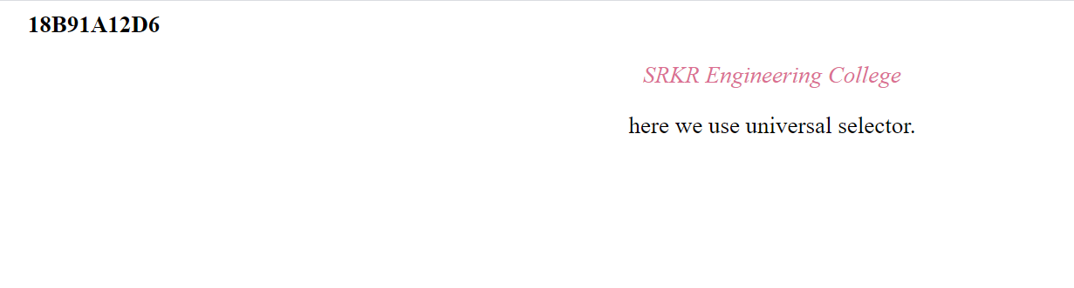

CSS2.html

<html>

    <head>

        <title>Group selectors</title>

        <style type="text/css">

             h1,p,h2

            {

                text-align: center;

                font-style:oblique;

                color:slateblue;

            }

h3{

           padding-left: 5%;

         }

        </style>

    </head>

    <body>

  <h3 style="text-align:left">18B91A12D6</h3>

        <h1>This is the h1 tag</h1>

        <p>This is the P tag</p>

        <h2>This is the h2 tag</h2>

    </body>

</html>

OUTPUT:

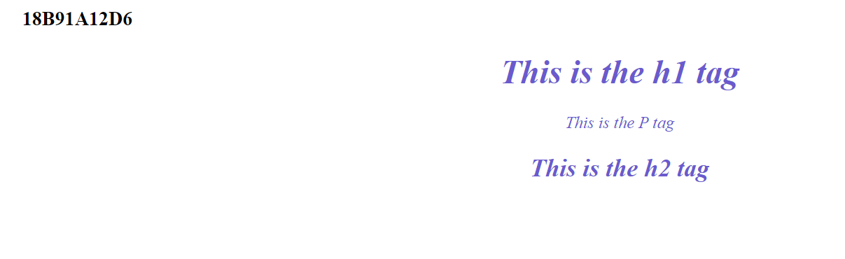

CSS3.html

<html>

    <head>

        <style>

            p.name

            {

                text-align: center;

                color:steelblue;

            }

            p.id2

            {

                font-size: 200%;

                color:violet;

            }

            h1.id1

            {

                font-style: inherit;

                color:tomato;

            }

h3{

           padding-left: 5%;

         }

        </style>

    </head>

    <body>

  <h3 style="text-align:left">18B91A12D6</h3>

        <h1 class="id1">This is h1 heading in tomato color and font style is inherit</h1>

        <p class="name">This paragraph will be steelblue and center-aligned.</p>

        <p class="id2">This paragraph will be violet, and with a font-size of 300%.</p>

    </body>

</html>

OUTPUT:

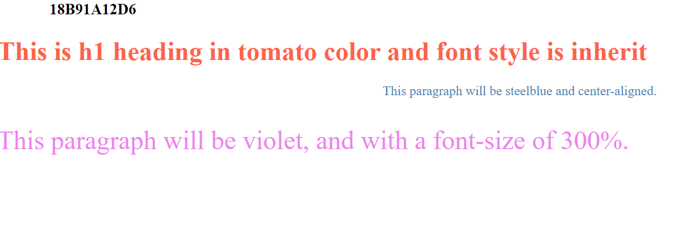

**LAB-3(JS)**

Vaccine Registration

<html>

    <head>

        <script>

            function vaccine(){

                var name=document.forms["register"]["username"].value;

                var ages=document.forms["register"]["age"].value;

                var adharnum=document.forms["register"]["adhar"].value;

                if(name.length<5)

                {

                    alert("Name must be more than 5 characters");

                    return false;

                }

                else if(ages<45)

                {

                    alert("Age must be above 45");

                }

                else if(adharnum.length<12)

                {

                    alert("Enter a vaild adhar number");

                }

               else{

                    var d1=document.getElementById("dose1");

                    if(d1.checked)

                    {

                        alert("You are successfully booked your slot for first dose");

                    }

                    var d2=document.getElementById("dose2")

                    if(d2.checked)

                    {

                        var firstdose=prompt("Enter your first dose date");

                        var parts=firstdose.split('-');

                        var mydate=new Date(parts[0],parts[1]-1,parts[2]);

                        console.log(mydate.getDate());

                        var cdate=new Date();

                        console.log(cdate.getDate());

                    }

               }

                var res=document.getElementById("res")

                res.innerHTML= name+ " "+ages+ " Successfully registered";

            }

        </script>

        <style>

            input[type=button]:hover{

                background-color: burlywood;

            }

        </style>

    </head>

    <body style="background-color:bisque">

        <div align="center">

  <h3>18B91A12D6</h3>

            <h1 style="color:rgb(235, 151, 41)">Registration for Vaccine</h1>

            <form name="register">

                <table border=0 cellpadding=1 width=50%>

                    <tr>

                        <th>Name</th>

                        <td>

                            <input type="textfield"  name="username">

                        </td>

                    </tr>

                    <tr>

                        <th>Age</th>

                        <td>

                            <input type="text" name="age">

                        </td>

                    </tr>

                    <tr>

                        <th>DOB</th>

                        <td>

                            <input type="date">

                        </td>

                    </tr>

                    <tr>

                        <th>Adhar Number</th>

                        <td>

                            <input type="text"  name="adhar">

                        </td>

                    </tr>

                    <tr>

                        <th>Vaccine</th>

                        <td>

 <input type="radio" id="dose1" name="vac" value="dose1">

                            <label for="dose1">First dose</label>

<input type="radio" id="dose2" name="vac" value="dose2">

                            <label for="male">Second dose</label>

                        </td>

                    </tr>

                </table>

                <div align="center">

                    <input type="button" id="txt" onClick="vaccine()" value="Register">

                    <input type="button" value="Reset">

                </div>

            </form>

        </div>

    <p id="res"></p>

    </body>

</html>

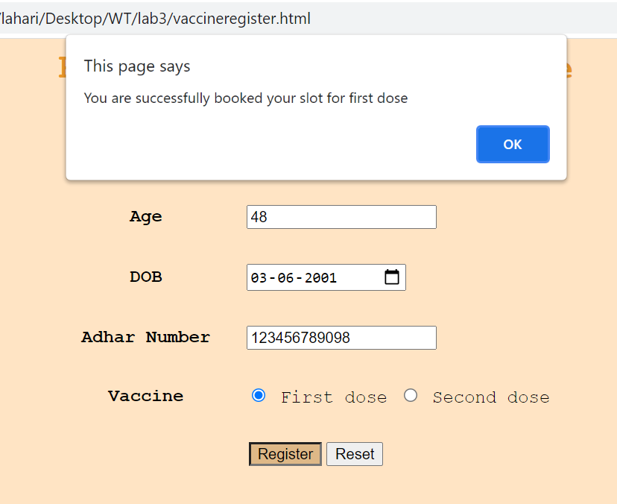

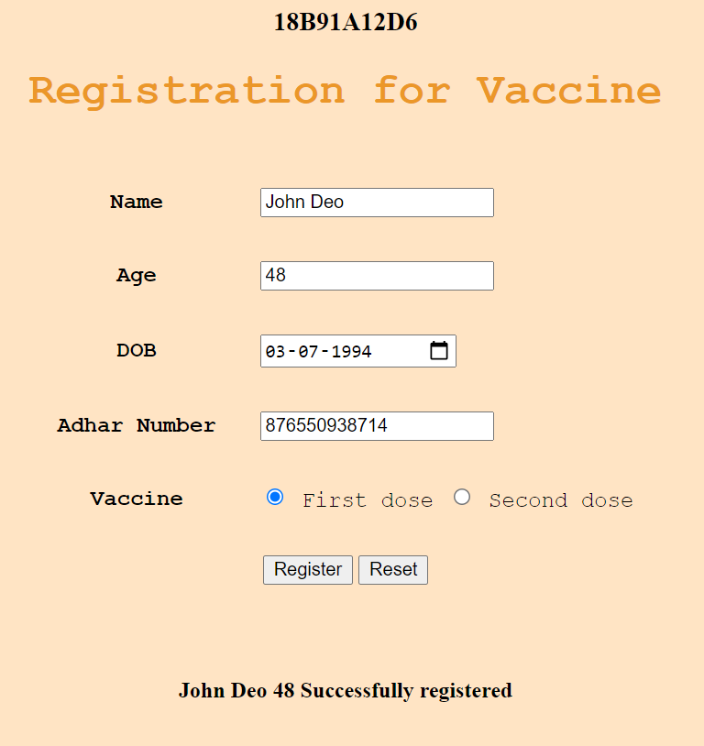

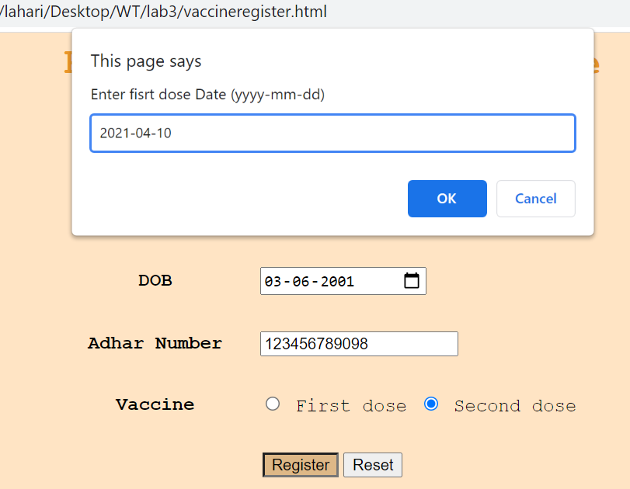  
  
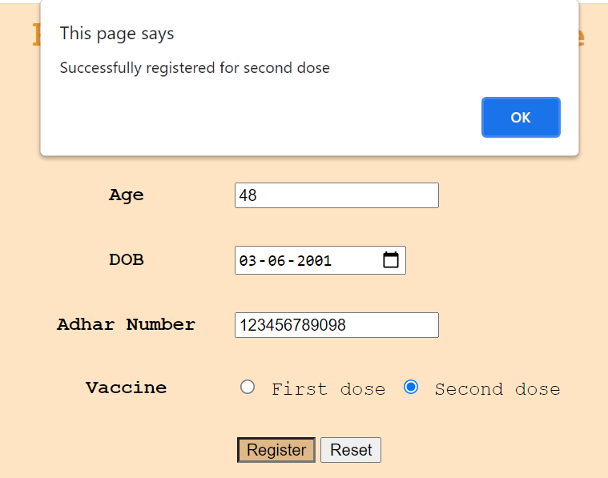  


**LAB-4(XML)**

WRITE AN XML file which will display the Book information which includes the following:

1) Title of the book

2) Author Name

3) ISBN number

4) Publisher name

5) Edition

6) Price

Write a Document Type Definition (DTD) to validate the above XML file.

<?xml version="1.0"?>

<!DOCTYPE book [

    <!ELEMENT book (bookinfo+) >

    <!ELEMENT bookinfo (title,author,ISBN,publisher,edition,price)>

    <!ELEMENT title (#PCDATA) >

    <!ELEMENT author (#PCDATA) >

    <!ELEMENT ISBN (#PCDATA) >

    <!ELEMENT publisher (#PCDATA) >

    <!ELEMENT edition (#PCDATA) >

    <!ELEMENT price (#PCDATA) >

]>

<book>

    <bookinfo>

        <title>Computer Networks</title>

        <author> Tanenbaum</author>

        <ISBN>123</ISBN>

        <publisher>Pearson</publisher>

        <edition>5th</edition>

        <price>₹880</price>

    </bookinfo>

    <bookinfo>

        <title>Web Technologies</title>

        <author> Sebesta</author>

        <ISBN>456</ISBN>

        <publisher>Pearson</publisher>

        <edition>3rd</edition>

        <price>₹6680</price>

    </bookinfo>

    <bookinfo>

        <title>UNIX Network Programming</title>

        <author> Bill Fenner </author>

        <ISBN>789</ISBN>

        <publisher>Addison-Wesley</publisher>

        <edition>2nd</edition>

        <price>₹450</price>

    </bookinfo>

    <bookinfo>

        <title>Programming Perl</title>

        <author>Randal L. Schwartz</author>

        <ISBN>167</ISBN>

        <publisher>O’Reilly Media, Inc.</publisher>

        <edition>1st</edition>

        <price>₹500</price>

    </bookinfo>

    <bookinfo>

        <title>File Structures</title>

        <author> Bill Zoellick</author>

        <ISBN>129</ISBN>

        <publisher>Pearson</publisher>

        <edition>5th</edition>

        <price>₹980</price>

    </bookinfo>

</book>

OUTPUT:

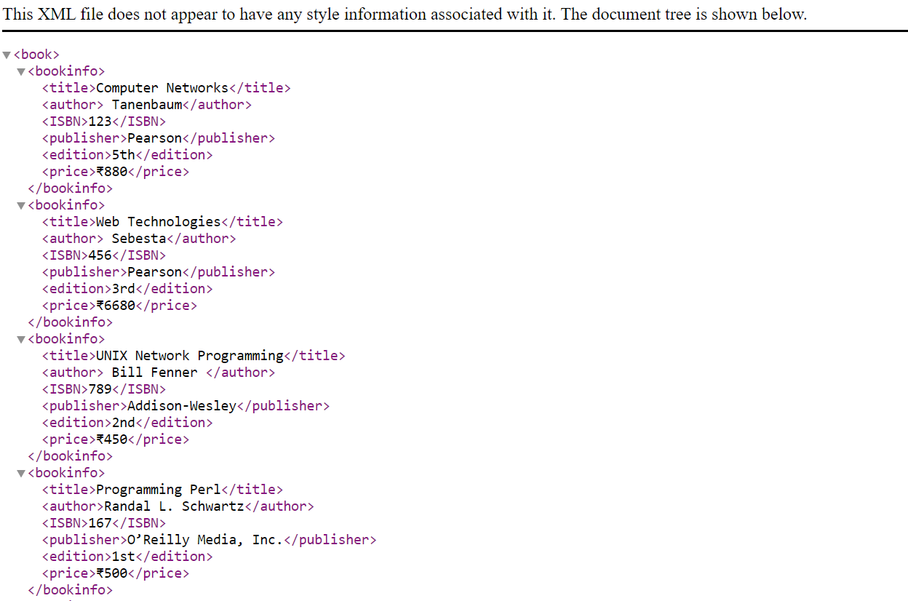

</book>

**Mycode.xsl**

<?xml version="1.0"?>

<xsl:stylesheet  xmlns:xsl="http://www.w3.org/1999/XSL/Transform">

 <xsl:template match="/">

        <html>

            <body>

                <table border="1">

                    <tr>

                        <th>Book Name</th>

                        <th>Author</th>

                    </tr>

                    <xsl:for-each select="library/book">

                        <tr>

                            <td><xsl:value-of select="name"/></td>

                            <td><xsl:value-of select="author"/></td>

                        </tr>

                    </xsl:for-each>

                </table>

            </body>

        </html>

    </xsl:template>

</xsl:stylesheet>

**Book.xml**

<?xml version="1.0"?>

<?xml-stylesheet type="text/xsl" href="mycode.xsl"?>

<library>

    <book>

        <name>Computer Networks</name>

        <author>Tanenbaum</author>

    </book>

    <book>

        <name>Web Technologies</name>

        <author>Sebesta</author>

    </book>

    <book>

        <name>UNIX</name>

        <author>Bill Fenner</author>

    </book>

    <book>

        <name>Programming Perl</name>

        <author>Randal L.Schwartz</author>

    </book>

</library>

**Output:**



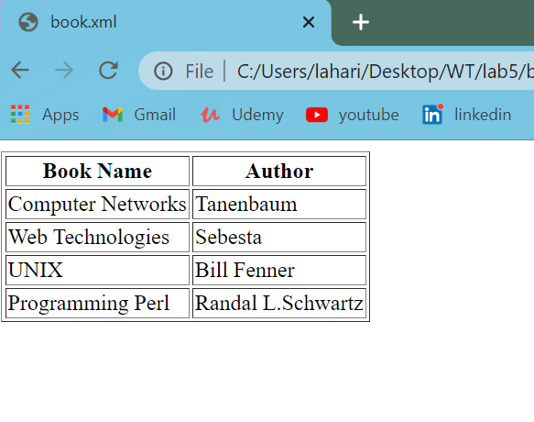

**LAB-5(RUBY)**

Write Ruby program reads a number and calculates the factorial value of it and prints the same.

puts "Enter number"

num = gets.chomp.to_i

fact=1

i=1

while(i <= num)

    fact=fact*i

    i=i+1

end

puts "Factorial of #{num} is #{fact}"

Output:

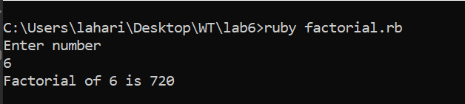

Write a Ruby program that uses iterator to find out the length of a string.

puts "Enter a string"

str=gets.chomp

count=0

str.split("").each do |i|

    count+=1

end

puts count

Output:

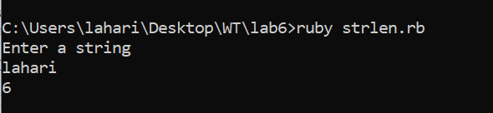

Write Ruby program which uses Math module to find area of a triangle.

 puts "Sides of triangle :"

a = gets.chomp.to_i

b = gets.chomp.to_i

c = gets.chomp.to_i

s = (a+b+c)/2;

puts "Value of s is #{s}"

area=Math.sqrt(s * (s-a) * (s-b) * (s-c))

puts "Area of triangle is #{area}"

Output:

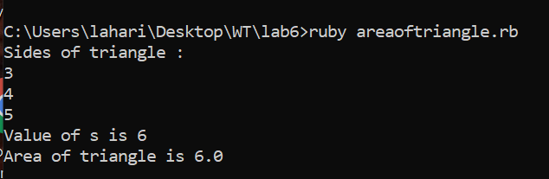

Write a Ruby program which counts number of lines in a text files using its regular Expressions facility.

**File1.txt**

WT

OR

DBMS

FS

CD

DWBI

SRP

C++

JAVA

DS

filename = "file1.txt"

count = IO.readlines(filename).size

puts "There are #{count} lines in #{filename}";

Output:

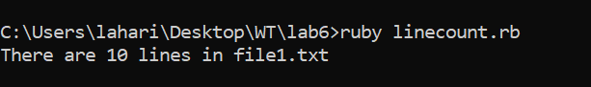

Write simple Ruby programs that uses arrays in Ruby.

puts "Bubble Sort"

print "Enter the size of the array:"

n=gets.to_i

a=Array.new(n)

puts "Enter the elements :"

    for i in 0..n-1

        a[i]=gets.to_i

    end

    t=0

    for i in 0..n-1

        for j in i..n-1

            if (a[i] > a[j])

                t=a[j]

                a[j]=a[i]

                a[i]=t

            end

        end

    end

puts "After Sorting :"

    for i in 0..n-1

        print "#{a[i]} "

    end

**Output:**

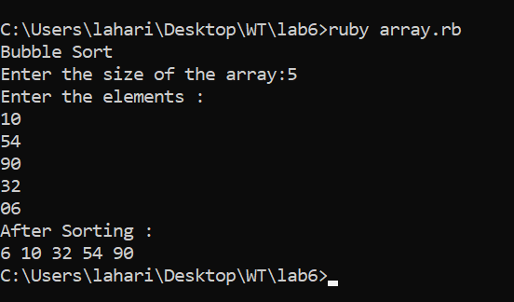

Write programs which uses associative arrays concept of Ruby.

shortcut = Hash.new;

shortcut = {"WT"=>"Web Technology","CN"=>"Computer Networks","OS"=>"Operating Systems"};

size = shortcut.length;

puts "Size of hash is: #{size}";

shortcut.each do |key,val|

puts "#{key} full form is #{val}"

end

**Output:**

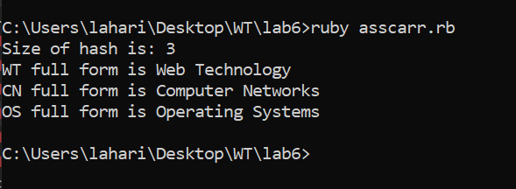

Write Ruby program which uses tk module to display a window

Define Complex class in Ruby and do write methods to carry operations on Complex objects

class Cmplx

    attr_accessor :real, :imag

    def read

        @real=gets.to_i

        @imag=gets.to_i

    end

    def add(other)

        ob = Cmplx.new

        ob.real = @real+other.real;

        ob.imag = @imag+other.imag;

        return ob

    end

    def subtract(other)

        ob = Cmplx.new;

        ob.real = @real-other.real;

        ob.imag = @imag-other.imag;

        return ob;

    end

    def multiply(other)

        ob = Cmplx.new

        ob.real = (@real * other.real)-(imag*other.imag);

        ob.imag = (@real * other.imag)+(imag*other.real);

        return ob;

    end

    def divide(other)

        t = Cmplx.new;

        ob = Cmplx.new;

        t.imag = -other.imag;

        r =(other.real).abs;

        i =(other.imag).abs;

        d =(r*r)+(i*i);

        ob.real = ((@real * other.real)-(imag*t.imag))/d;

        ob.imag = ((@real * t.imag)+(imag*other.real))/d;

        return ob;

    end

    def disp

        if @imag<0

            puts "#{@real}#{@imag}i"

        else

            puts "#{@real}+#{@imag}i"

        end

    end

end

t1 = Cmplx.new

t2 = Cmplx.new

t3 = Cmplx.new

t4 = Cmplx.new

t5 = Cmplx.new

t6 = Cmplx.new

puts "Enter first number"

t1.read

puts "Enter Second number"

t2.read

print "FIRST NUMBER:"

t1.disp

print "SECOND NUMBER:"

t2.disp

print "ADDITION:"

t3 = t1.add(t2)

t3.disp

print "SUBTRACTION:"

t4 = t1.subtract(t2)

t4.disp

print "PRODUCT:"

t5 = t1.multiply(t2)

t5.disp

print "DIVSION:"

t6 = t1.divide(t2)

t6.disp

Output:

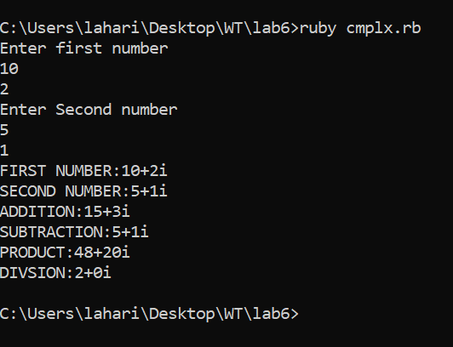

**LAB-6(PHP)**

**Form.html**

<html>

    <body>

       <form action=submit.php method="post">

        <pre>18B91A12D6</pre>

        Enter FirstName:<input type="text" name="a"/><br><br>

        Enter LastName:<input type="text" name="b"/><br><br>

        <input type="submit" name="sub" value="click"/>

      </form>

    </body>

</html>

**Output:**

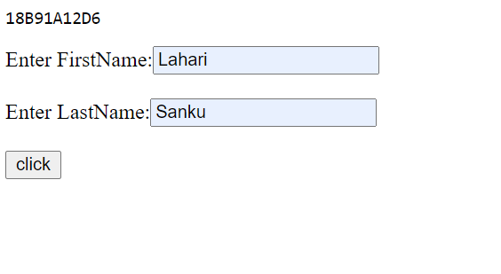

**Submit.php**

<?php

    $a=$_POST["a"];

    $b=$_POST["b"];

    echo "Hello ".$a." ".$b;

?>

**Output:**



**Self.php**

<html>

    <body>

        <pre>18B91A12D6</pre>

    <?php if ($_SERVER['REQUEST_METHOD'] === 'GET'){?>

      <form action="<?php $_SERVER['PHP_SELF'] ?>" method="post">

        Enter FirstName:<input type="text" name="a"/><br><br>

        Enter LastName:<input type="text" name="b"/><br><br>

        <input type="submit" name="sub" value="click"/>

      </form>

      <?php }else{

        $a=$_POST["a"];

        $b=$_POST["b"];

        echo "Welcome ".$a." ".$b;

      }

     ?>

    </body>

</html>

**Output 1:**

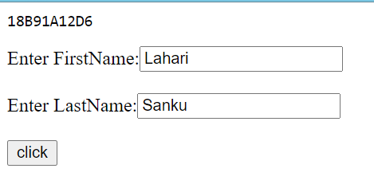

**OUTPUT 2:**



Ajax.html

<html>

 <head>

 <script type='text/javascript' src='ajax.js'></script>

 <title>PHP AJAX Example</title>

 </head>

<body>

 <input type='button' onclick='MakeRequest();' value='Use AJAX!!!!'/>

 <div id='ResponseDiv'>

 This is a RAGHU to hold the response.

 </div>

 </body>

</html>

Ajax.js

function MakeRequest()

{

 var xmlHttp;

try

 {

 xmlHttp = new XMLHttpRequest();

 }

 catch(e)

 {

alert("Your browser does not support AJAX!")

 }

 xmlHttp.onreadystatechange = function()

 {

 if(xmlHttp.readyState == 4)

{

 HandleResponse(xmlHttp.responseText);

}

 }

 xmlHttp.open("GET", "server.php", true);

 xmlHttp.send(null);

}

function HandleResponse(response)

{

 document.getElementById('ResponseDiv').innerHTML = response;

}

Ajax.php

<?php

header('Access-Control-Allow-Origin: *');

echo "This is a php response to your request!!!!!!";

?>

Insert.php

<?php

    $server="localhost";

    $user="root";

    $pass="";

    $dbname="raghu";

    $con =mysqli_connect($server,$user,$pass,$dbname);

    if(!$con)

    {

        die("Error : :  ".mysqli_connect_error());

    }

    $sql = "INSERT INTO student VALUES ('{$_POST['id']}','{$_POST['name']}','{$_POST['marks']}')";

    $res = mysqli_query($con,$sql);

    if($res)

    {

       $sql2="select * from student";

       $sres=mysqli_query($con,$sql2);

       echo "<table border=1>

               <tr>

                <th>ID</th>

                <th>Name</th>

                <th>Marks</th>

               </tr>";

       while($row= mysqli_fetch_array($sres))

       {

           echo "<tr>";

           echo "<td>".$row[0]."</td>";

           echo "<td>".$row[1]."</td>";

           echo "<td>".$row[2]."</td>";

           echo "</tr>";

       }

       echo "</table>";

    }

    else

    {

        echo "Issue with query";

    }

    mysqli_close($con);

?>

Insertform.html

<html>

    <body>

        <form action="insert.php" method="post">

            ID <input type="text" name="id"/><br>

            Name <input type="text" name="name"/><br>

            Marks <input type="text" name="marks"/><br>

            <input type="submit" value="insert"/><br>

        </form>

    </body>

</html>

Perl and ruby

15

%myassarr=("wt"=>"web tech",

            "cn" => "comp netw" );

if(exists $myassarr{sb})

{

    print "element found\n";

}

else

{

    print "element not found\n";

}

$myassarr{"c"}="c program";

if(exists $myassarr{c})

{

    print "element found\n";

}

else

{

    print "element not found\n";

}

delete($myassarr{"c"});

if(exists $myassarr{c})

{

    print "element found\n";

}

else

{

    print "element not found";

}

op:

C:\Users\srkr\Desktop\perl>perl [first.pl](http://first.pl/)  
element not found  
element found  
element not found

2. 16

$n1=@ARGV[0];

$op=@ARGV[1];

$n2=@ARGV[2];

$ans=0;

if($op eq '+')

{

    $ans=$n1+$n2;

    print "addition : $ans";

}

elsif($op eq '-')

{

    $ans=$n1-$n2;

    print "subtraction : $ans";

}

elsif($op eq '*')

{

    $ans=$n1*$n2;

    print "multiplication : $ans";

}

else

{

    print "invalid operator!!!";

    exit;

}

op:

C:\Users\srkr\Desktop\perl>perl [second.pl](http://second.pl/) 5 - 3  
subtraction : 2

3,14 complex class

class Myclass

    @@clsvar=0;

    def initialize(name,id)

        @std_name=name

        @std_id=id

    end

    def total

        @@clsvar+=1

        print "#{@@clsvar}\n"

    end

end

obj=Myclass.new("vnk","1")

obj1=Myclass.new("vnk1","11")

obj.total

obj1.total

op:

C:\Users\srkr\Desktop\perl>ruby complex.rb  
1  
2

|  |  |
| --- | --- |
|  | ReplyReply to allForward |